Name: Class:

Task 1
The following table shows a list of rules on each row. It then shows a goal that you need to prove using deduction. Write if the goal is True or False in the final column.
Rules | Goal | Use reasoning/deduction to find if the goal is True or False
- All zebras have black stripes.  - All zebras have white stripes. | All zebras have black and white stripes.
- Jonny likes tea.  - Amy likes coffee.  - Tea and coffee are both hot drinks.  - Jonny and Amy are the only people to live at 24 Crescent Drive. | Everyone who lives at Crescent Drive likes hot drinks.
- George has one child.  - George’s grandson is Arthur.  - Arthur’s mother is Olivia.  - Olivia’s daughter is called Isla.  - Isla is related to George. | Isla is Olivia’s sister.
- The local swimming pool is open between 8am and 8pm.  - The local swimming pool isn’t open on Mondays.  - The time now is currently 9am.  - Today is a bank holiday Monday. | The swimming pool is open.

Task 2
The following rules have been added to an AI program to detect whether a shape is a black square.
- All black pixels must have exactly two black pixels next to them.
- All black pixels, except four, must have two white pixels at opposite sides and two black pixels at opposite sides.
- A corner is a black pixel that has another black pixel adjacent to it.
- All distances between corner pixels must be the same.
Look at each of the following shapes represented with pixels. State whether each one is a black square (according to the rules). If a shape isn’t a black square, state which rule(s) stop it from being one and explain how the rule(s) have been broken.
Shape | Is it a black square? | If it isn’t a black square, which rule decides this?

Task 3
The following shows the data and rules of an expert system arranged as a tree.
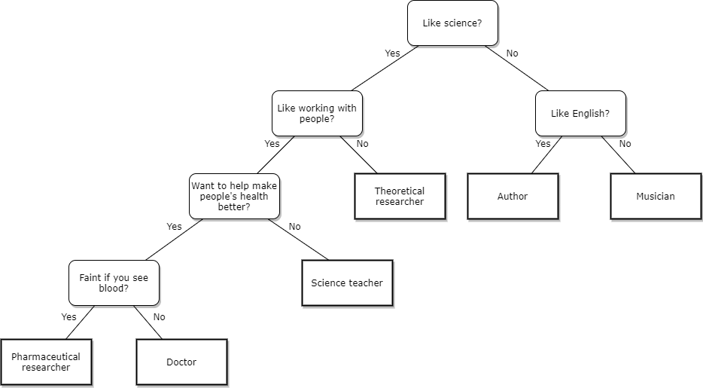
(a) Show how the inference engine uses forward chaining to establish the most appropriate career for someone who likes working with people but isn’t interested in a job that makes people’s health better. They also like science.

(b) The RSPB has an expert system that helps the public to identify birds.
Visit the website:
https://www.rspb.org.uk/birds-and-wildlife/wildlife-guides/identify-a-bird/
A photo has been taken of a bird in a local park. Use the expert system to identify the following bird:
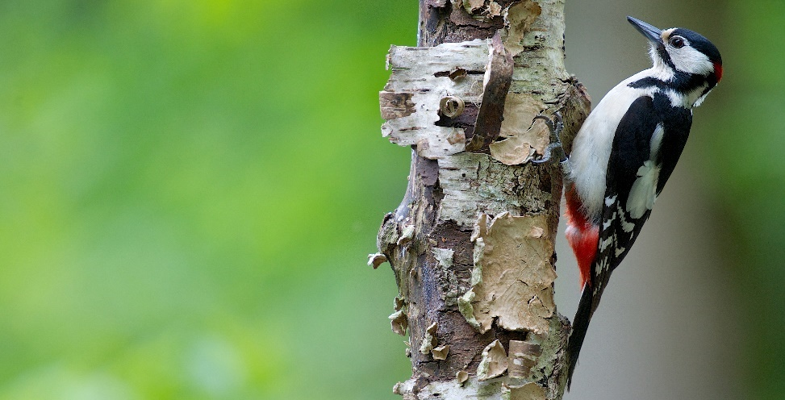
Bird identified:

(c) Discuss ideas that may improve this expert system so that it is easier to use.

Task 4
The following table shows eight images that have been used as training data for a machine learning program.
Training data for dogs
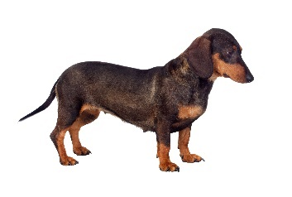 | 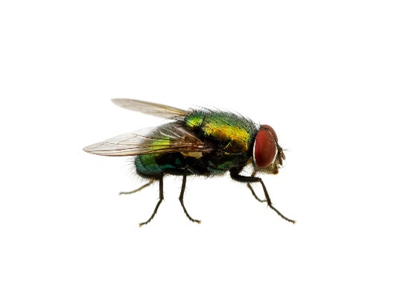 | 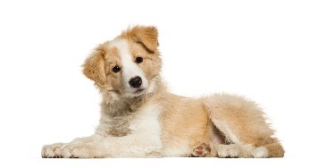 | 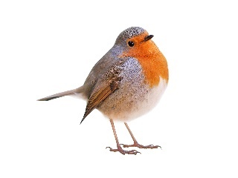
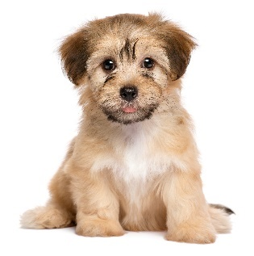 | 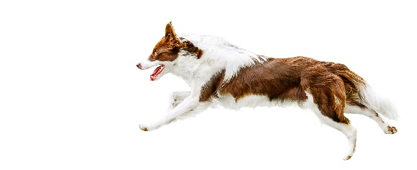 | 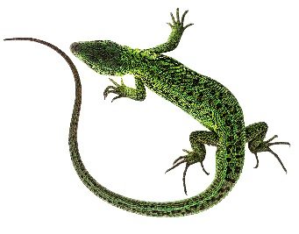 | 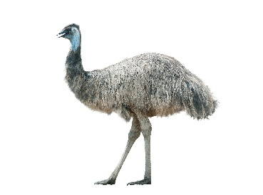
In machine learning the computer program will look at the training data and ‘discover’ rules to classify dogs.
(a) Use the training data to determine five rules that can be used to classify dogs.

(b) Look at the following photos.
Complete the table to show which which rules the photo meets and work out a percentage of certainty that the photo shows a dog (based on your rules).
 | 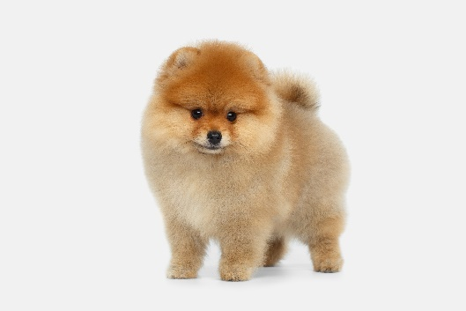 | 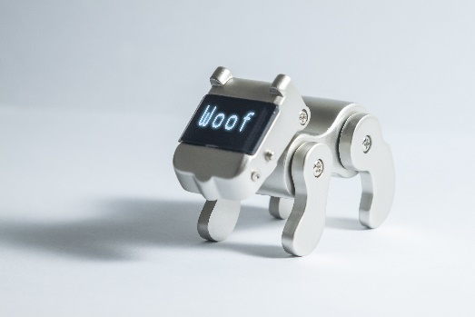 | 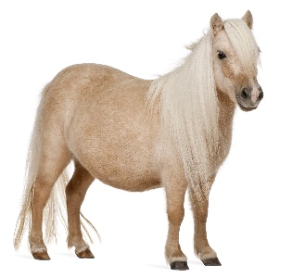
Rules met
Percentage certainty the image is a dog

(c) Explain how the machine learning could be improved.

